**Debugging Commons Problems**

Some of the most common errors and their solutions are posted below. You can refer to this page anytime you are facing issues while executing your Python code. If you have any other problems, or if you want more help, please let us know and we'll be happy to help you out.

In most cases, the python interpreter tells you where the probable error might lie. It will even tell you the line in the file and the probable cause of it. How cool is that?

**Command not found error:**

During executing the command to run a python file, you may face an error saying "**command not found**" as shown below.

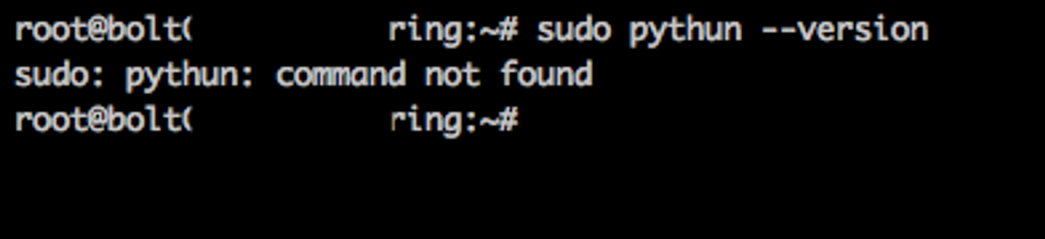

There can be multiple reasons for this error,

1. The command is not typed correctly. To fix this, re-type the command correctly. Check for each spelling and ensure that you have not missed out any special characters, spaces, hyphens or capitalization in the command.
2. `sudo` keyword is missing at the beginning of the command. To fix this add `sudo` keyword at the beginning of the command and run the command again.
3. The required package or software is not installed. To fix this, run the command to install the required software or package.

2. **Python pip upgrade error:**

During installation of any python module via the pip command, you may get a screen that tells you that pip may need to be upgraded as shown below,

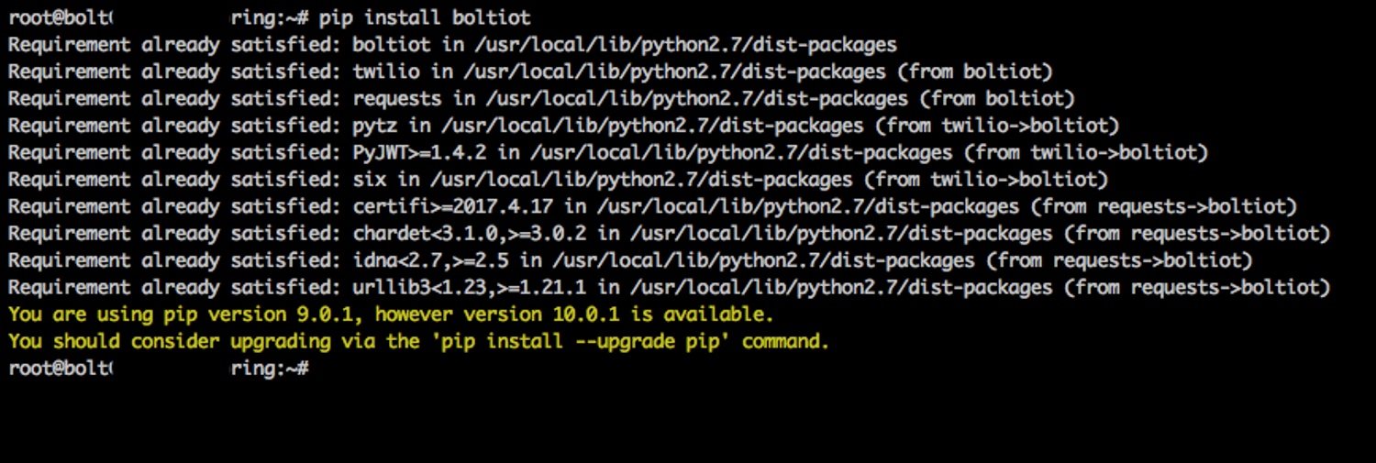

Not to worry, this is just a warning and you may **ignore** this message.

3. **Indentation error:**

You may get a message after giving the command to execute your python code as shown below

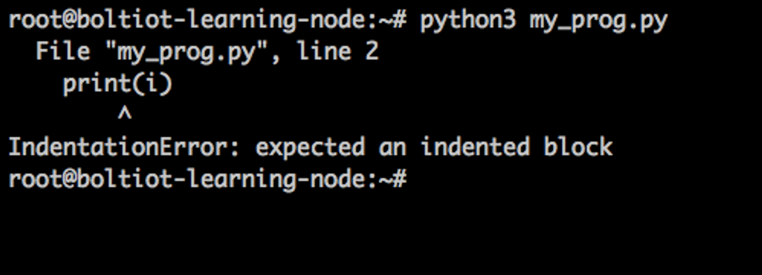

Check your code to see if the spacing in the code is proper. The most probable cause may be that the code is not structured properly using the spaces.

Python is awesome, it also tells you where the error might be. As you can see in the image above, the error is in file "my_prog.py" at line 2. It also prints the line for your reference and shows what the reason might be. You can always correct your code by looking at this statement.

You may refer to the previous section to know more about Indentation in Python. You will have to indent your code and then you will be able to get the output.